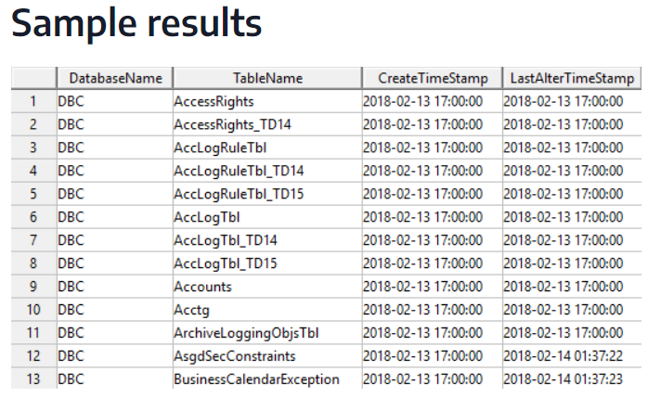**Task: 1 list of table names in schema**

SELECT DatabaseName,

TableName,

CreateTimeStamp,

LastAlterTimeStamp

FROM DBC.TablesV

WHERE TableKind like 'T%'

Task :2 Task2: check all tables in schema

**Task3:--** select * from Sri. Friends

**health care check ip op and drug :--**

Sure! Here’s a brief explanation of these terms in the context of healthcare:

1. **Inpatient (IP)**: When a patient is admitted to the hospital and stays overnight or for multiple days, they are considered an inpatient1. This usually involves more intensive care and monitoring1.
2. **Outpatient (OP)**: Outpatient care refers to medical services provided to patients who do not require an overnight stay in the hospital2. Examples include routine check-ups, minor surgeries, and diagnostic tests2.
3. **Observation Status**: This is a middle ground between inpatient and outpatient care3. Patients under observation are typically kept in the hospital for a short period (usually 24-48 hours) to determine if they need to be admitted as inpatients or can be discharged1.
4. **Drug**: In healthcare, a drug refers to any substance used to diagnose, cure, treat, or prevent disease2. This includes prescription medications, over-the-counter drugs, and other therapeutic substances.



**INFORMATICA**

Informatica is a tool that can be used to extract, transform, and load data into a target system. Here are some ways to use Informatica:

* **Set up Informatica Developer**: This involves adding a domain, model repository, project, and folder, and selecting a default data integration service.
* **Import physical data objects**: This involves importing data objects such as flat file data objects.
* **Run a profile on source data**: This involves performing a join analysis on two data sources, viewing the results, and running a profile on a data source.
* **Connect to a database**: This involves creating an ODBC connection object for each database and connecting to the database.
* **Load data from a flat file**: This involves clicking on Import from file to load data from a flat file.
* **Use the administrative tool**: This involves installing Informatica Power Center on a system, specifying the host name and connection port, and logging in to the administrative console.